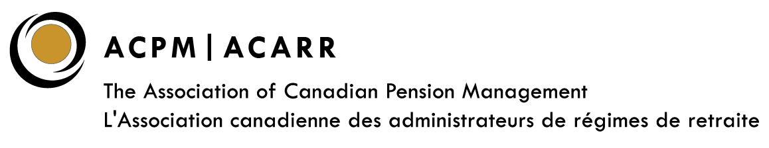

2023 ACPM Volunteer Recognition Awards
Nomination Form

Please provide as much detail whenever possible.

To be a Nominator, you must be an ACPM Member in good standing. Members of the Awards Committee cannot be a Nominator or be nominated for an award. Please contact us if you have any questions or require more information. Click HERE for more information on the ACPM Volunteer Recognition Awards Program. Thank you and we look forward to your nominations.

Nominations should be submitted no later than Friday, August 4, 2023, to volunteeraward@acpm.com

Nomination for (double click on the box to select one option):

The Don Ireland Award for Exceptional Volunteerism

ACPM Industry Award

ACPM Council Award

Alberta Regional Council | Atlantic Regional Council | BC Regional Council
Federal Council | Ontario Regional Council | Prairie Regional Council
Québec Regional Council

Name of Nominator:
Organization:
Phone Number:
Email:

Name of Nominee:
Organization:
Phone Number:
Email:

- Is the Nominee currently involved with ACPM and in what capacity?

- Has the Nominee served on ACPM National Committees/ Councils/Task Forces/Sub-committees in the past?

- What have been the Nominee’s contributions and/or achievements?

- Any Other Comments?

THANK YOU FOR YOUR SUBMISSION!

